Extended Abstract Template For E3CN’26

(within 3 pages)
Title: Numerical Analysis of Severe Slug Flow in Parallel Tube-Bundles during Molten-Salt Filling of CSP Collector
(Title: no strict word‑count limit; keep concise, generally ≤15 content words, 15 pt, Bold)
Authors: Mark Carter¹*, Brian Hoffman¹ (10.5 pt)
¹ School of Mechanical and Mining Engineering, The University of Queensland, Brisbane, QLD 4072, Australia(10.5 pt)
*Corresponding author: mark.carter@uq.edu.au(10.5 pt)
Keywords: molten salt; filling process; severe slug flow; gas‑liquid two‑phase flow; VOF model; parallel tube bundles
(Keywords: 3‑6 items, not counted in main‑body word count, 10.5 pt)

1. Introduction (14 pt, Bold)
(State background, research gap and objective; avoid exhaustive literature review, approximately 250–350 words, 12 pt , 1.2-line spacing)
Molten‑salt thermal storage is a key technology for concentrating solar power systems. During the initial filling procedure of Fresnel collector fields, molten salt displaces the original air inside complex pipe networks consisting of horizontal distribution pipes, vertical riser/downcomer tubes and long horizontal parallel tube bundles. Periodic gas‑liquid plug movement occurs, giving rise to violent pressure oscillation and uneven flow distribution among multiple branches, which threatens the flow safety of the whole collector field.
Existing studies on severe slug flow mainly concentrate on simple “horizontal‑vertical riser” configurations. Less attention has been paid to multi‑parallel tube‑bundle structures, and the dominating similarity criteria for cold‑model experimental reproduction remain insufficiently discussed. This work aims to numerically reveal the generation and evolution mechanism of severe slug flow in such multi‑branch piping system, and analyze the controlling effect of dimensionless numbers on two‑phase flow behaviors during filling.

2. Methodology (14 pt, Bold)
(Describe geometry, numerical model, boundary conditions, thermophysical properties and dimensionless analysis; omit trivial operational details, approximately 300‑400 words, 12 pt, 1.2-line spacing)
A three‑dimensional geometric model reproduces the actual layout: horizontal distribution pipe, 2 m‑high vertical upward tube bundles, long horizontal parallel tubes, vertical downward tube bundles and a collecting header. The Volume‑of‑Fluid (VOF) multiphase flow model is adopted to track the gas‑liquid interface. Temperature‑dependent thermophysical properties of binary nitrate molten salt are implemented. Pressure‑inlet and pressure‑outlet boundaries are applied. Mesh independence verification is carried out to eliminate grid‑size influence.
Dimensionless analysis is performed in this study. Froude number (Fr), Reynolds number (Re) and Bond number (Bo) are calculated using pipe inner diameter as the characteristic length. Fr characterizes inertia‑gravity competition and governs macroscopic gas‑liquid interface migration and slug oscillation. Re reflects viscous resistance and branch‑tube flow distribution. The Weber number associated with surface tension only dominates micro‑scale interface deformation and is not the controlling parameter for this large‑scale filling process.

3. Results and Discussion (14 pt, Bold, 0.5-line spacing before and after paragraph)
(Present observed phenomena, quantitative results, physical mechanism and similarity analysis. One or two figures or tables can be embedded in this section to demonstrate flow patterns or pressure‑time curves; keep figure captions brief, approximately 300-400 words, 12 pt, 1.2-line spacing.)
Complete periodic cycles of severe slug flow are captured, including gas‑plug accumulation, liquid‑plug growth, blow‑out and re‑accumulation stages. Alternating gas‑liquid plugs propagate through distribution pipes and vertical branches and trigger obvious periodic pressure fluctuation at the header. For parallel tube bundles, gas‑blocking inside partial branches leads to non‑uniform flow‑rate distribution among different channels. Typical flow morphology and pressure oscillation characteristics are illustrated in Fig.1 and Fig.2.
Numerical results demonstrate that Froude number acts as the dominant dimensionless parameter for reproducing macroscopic slug‑flow patterns and gas‑exhaust rhythm. Reynolds number mainly determines pressure loss and flow partitioning. Simultaneous matching of both Fr and Re cannot be achieved in water‑based cold‑model experiments owing to the large viscosity difference between water and high‑temperature molten salt, as shown in Tabel 1. If only Fr similarity is satisfied, macroscopic gas‑liquid evolution can be qualitatively reproduced, whereas viscous‑dominated resistance will deviate from prototype conditions.
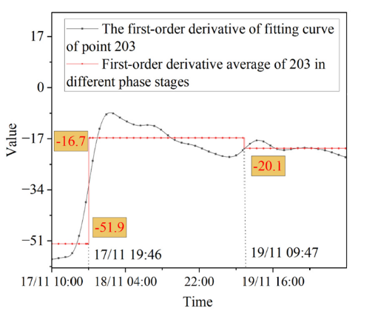
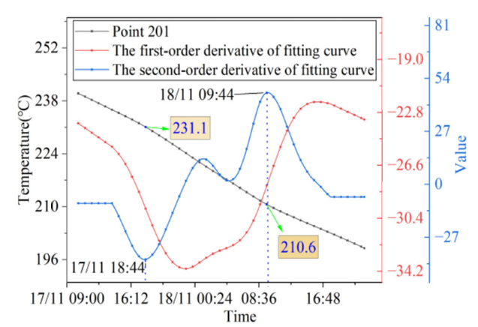
Fig. 1 Temperature and its first and second Fig. 2 Average values of the first derivative
(Figures in 10.5 pt and 0.5-line spacing before and after paragraph)
Table 1: Comparison of this work with recent literature (10.5 pt in Table)
Catalyst/Method | Efficiency / Capacity | Stability (Hours) | Reference
Method A | 85% | 10 | [1]
Method B | 88% | 20 | [2]
This Work | 95% | 50 | -

4. Conclusions (14 pt, approximately 200‑300 words, 0.5-line spacing before and after paragraph)
(Summarize key findings, engineering implications and outlook; no new results introduced, 12 pt, 1.2-line spacing.)
(1) In parallel tube‑bundle systems for molten‑salt filling, severe slug flow originates from combined horizontal‑vertical geometry and multi‑branch layout, inducing pressure oscillation and branch flow maldistribution.
(2) Fr number governs macroscopic gas‑liquid plug motion and gas‑exhaust rhythm; Re number controls viscous loss and flow distribution. Weber number plays a minor role for this large‑scale piping.
(3) Double similarity of Fr and Re cannot be satisfied in water cold‑model tests. Adopting Fr as the primary similarity criterion provides a feasible compromise for slug‑flow mechanism investigation.
This work offers references for operational safety of Fresnel collector fields. Cold‑model experimental validation will be conducted in future research.

Acknowledgements (14 pt, 0.5-line spacing before and after paragraph)
This work was supported by XXX Foundation (Grant No. XXXXXXXX).(12 pt, 1.2-line spacing.)

References

(3‑6 references recommended, 1.2-line spacing)
[1] Brown R, Miller S, Davis K. Gas‑liquid two‑phase flow characteristics during molten‑salt filling in solar thermal systems. Solar Energy, 2024, 268: 112345.
[2] Harrison J, Thompson L. Severe slug flow in horizontal‑vertical riser pipes: A review. Chemical Engineering Science, 2023, 272: 118562.
[3] Wilson P, Garcia M. Similarity analysis of gas‑liquid displacement flow for molten‑salt cold‑model experiment. Heat Transfer Engineering, 2025, 46(8): 641‑652.

Format notes for within‑3‑page submission
- Font: Times New Roman
- Page margin: 2.5 cm on four sides
- 1‑2 figures or tables are allowed, placed within the Results and Discussion section. Avoid oversized figures to ensure the whole manuscript fits in two pages.
- All contents including title, authors, figures, acknowledgements and references shall be contained within two pages.

